Customer Shopping Behaviour Analysis

1. Project Overview
This project focuses on analyzing customer shopping behavior using a transactional dataset comprising approximately 3,900 purchase records across multiple product categories. The primary objective is to derive actionable insights into customer spending habits, segmentation patterns, product preferences, and subscription trends, ultimately supporting data-driven business decision-making.

2. Dataset Description
- Rows: 3,900
- Columns: 18
Key Attributes Include:
- Customer Demographics: Age, Gender, Location, Subscription Status
- Transaction Details: Product Name, Category, Purchase Amount, Season, Size, Colour
- Behavioural Metrics: Discount Usage, Purchase Frequency, Previous Purchases, Review Ratings, Shipping Preferences
Data Quality Note:
- Identified 37 missing values in the Review Rating column, which were addressed during pre-processing.

3. Data Pre-processing & Exploratory Data Analysis (Python)
Data cleaning and exploratory analysis were conducted using Python to ensure data integrity and usability.
- Data Loading: Loaded dataset using Pandas for structured analysis.
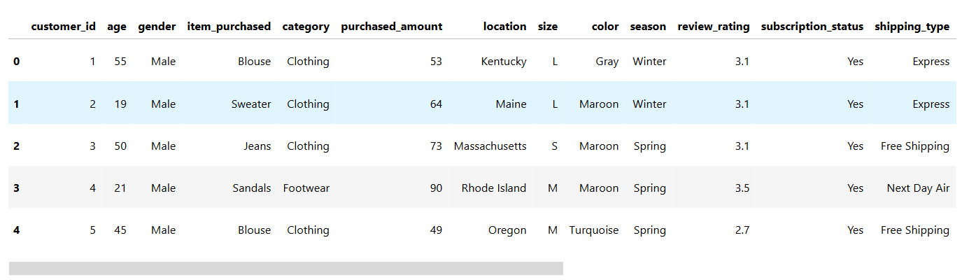
- Initial Assessment: Evaluated dataset structure using .info() and statistical summaries via .describe().
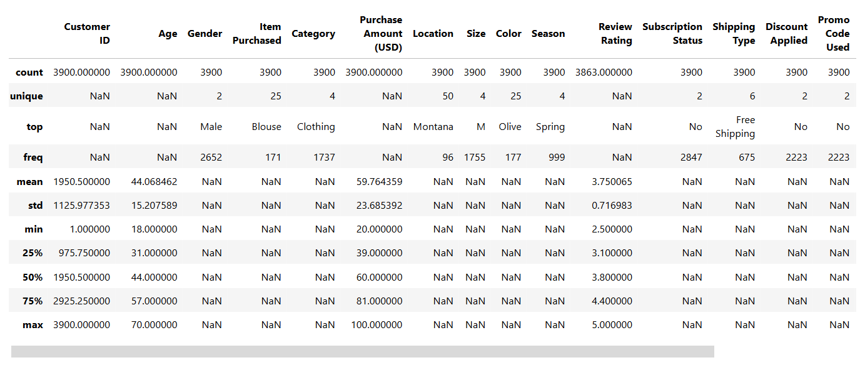
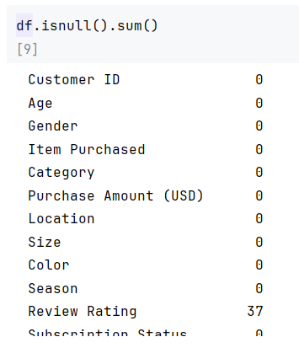

- Handling Missing Values: Checked for null values and imputed missing values in the Review Rating column using the median rating of each product category.

- Column Standardization: Renamed columns to snake_case for better readability and documentation.

- Feature Engineering:
  - Created an age_group variable by categorizing customers into age brackets.

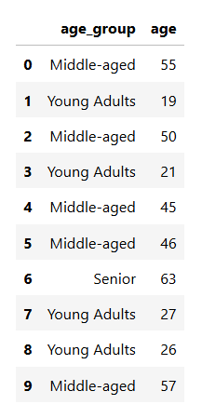
  - Derived purchase_frequency_days to quantify customer buying intervals.

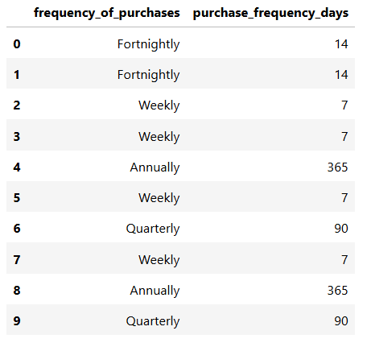

Payment Method Analysis: Identified which payment method is more utilised for the purchase
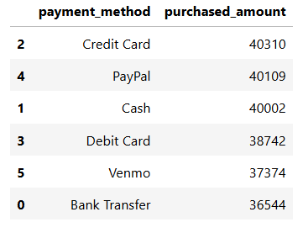

Rating Vs Spending Analysis :
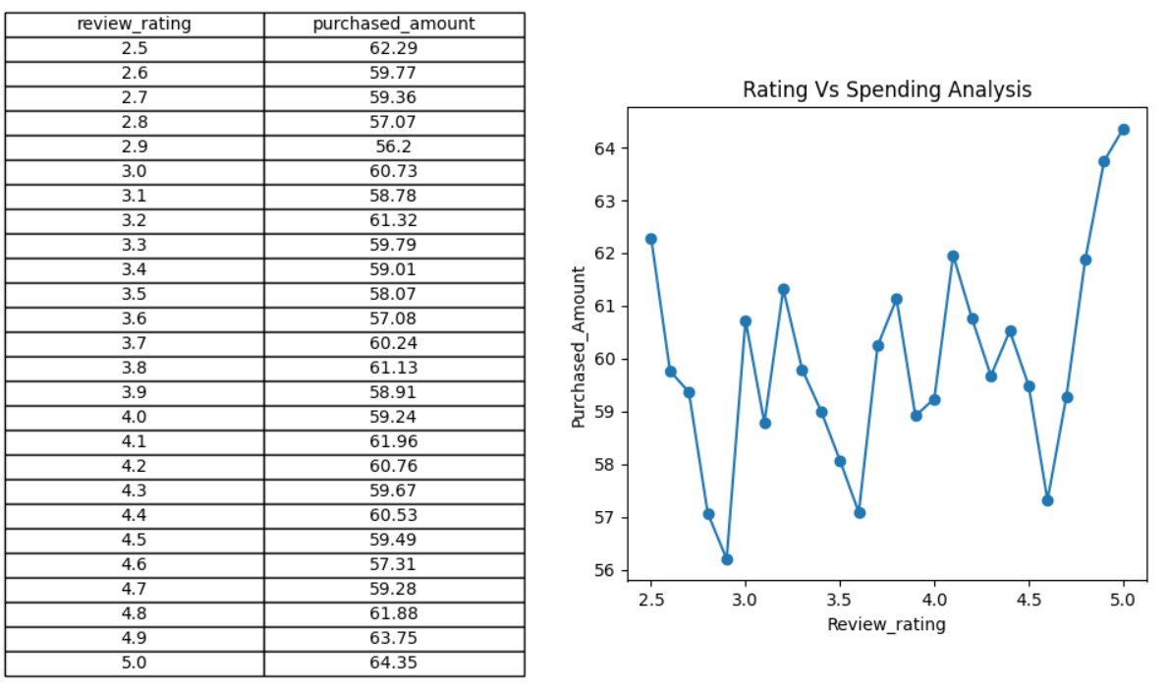

- Data Validation:
Identified redundancy between discount_applied and promo_code_used, leading to the removal of the less informative feature.
- Database Integration:
The cleaned dataset was exported and stored in a MySQL database to facilitate advanced querying and analysis.

4. Business Analysis Using MySQL
Advanced analytical queries were performed in MySQL to extract key business insights:
- Revenue Distribution by Gender: Compared total revenue contribution across male and female customers.
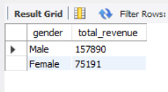
- High-Value Discount Users: Identified customers who utilized discounts yet maintained above-average spending levels.
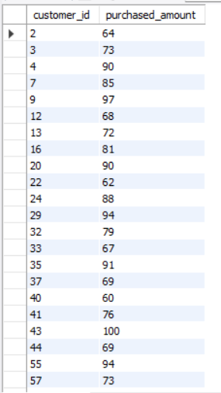
- Top-Rated Products: Ranked products based on average customer review ratings.
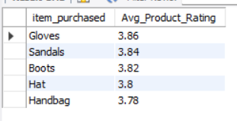
- Shipping Preference Analysis: Evaluated differences in purchase value between Standard and Express shipping options.

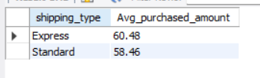

- Subscription Impact Analysis: Assessed spending patterns and revenue contribution of subscribers versus non-subscribers.

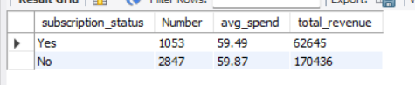
- Discount Sensitivity Analysis: Determined products most frequently purchased under discount conditions.
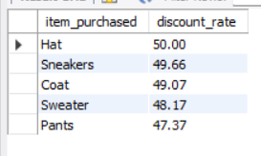
- Customer Segmentation: Classified users into New, Returning, and Loyal categories based on purchase frequency.

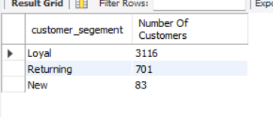

- Category-Level Product Performance: Identified top-performing products within each category.

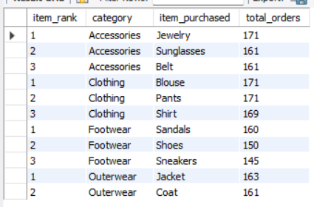

- Repeat Purchase Behaviour: Analyzed correlation between high purchase frequency (>5 purchases) and subscription likelihood.
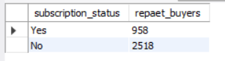

- Revenue by Age Segment: Measured contribution of different age groups to overall revenue.
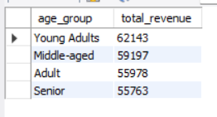

5. Data Visualization (Power BI Dashboard)
An interactive dashboard was developed using Power BI to present insights in a visually intuitive format.
The dashboard includes:
- Revenue trends and KPIs
- Customer segmentation visuals
- Product performance analysis
- Behavioural insights (discount usage, shipping trends)

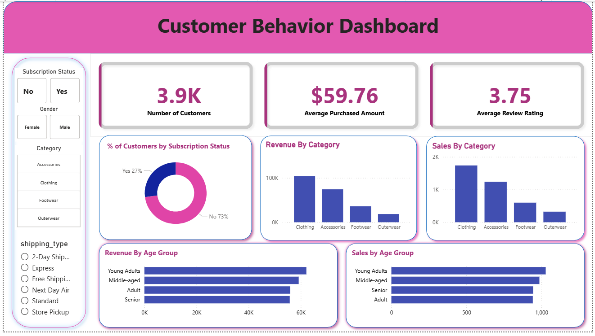

6. Strategic Recommendations
Based on the analysis, the following business strategies are recommended:
- Enhance Subscription Programs:
Introduce exclusive incentives to increase subscriber conversion rates.

- Strengthen Customer Retention:
Implement loyalty programs targeting repeat customers to transition them into high-value segments.

- Optimize Discount Strategy:
Balance promotional offers to maximize revenue without compromising profit margins.

- Improve Product Marketing:
Highlight top-rated and best-selling products in promotional campaigns.

- Targeted Customer Engagement:
Focus marketing efforts on high-revenue demographics and customers preferring express delivery.

